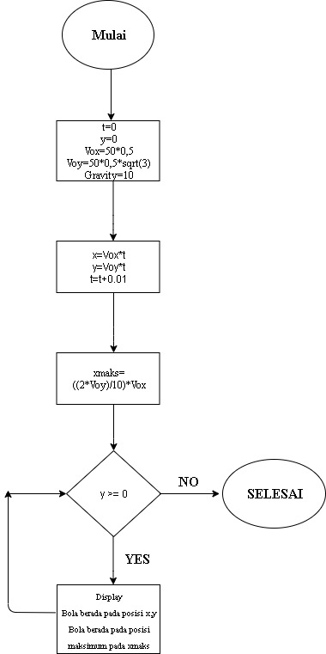Diagram Flow Chart Kuis 1